User Guide:

Step One:

Installation of PostgreSQL

Head to www.google.com

Search PostgreSQL

Click https://www.postgresql.org/

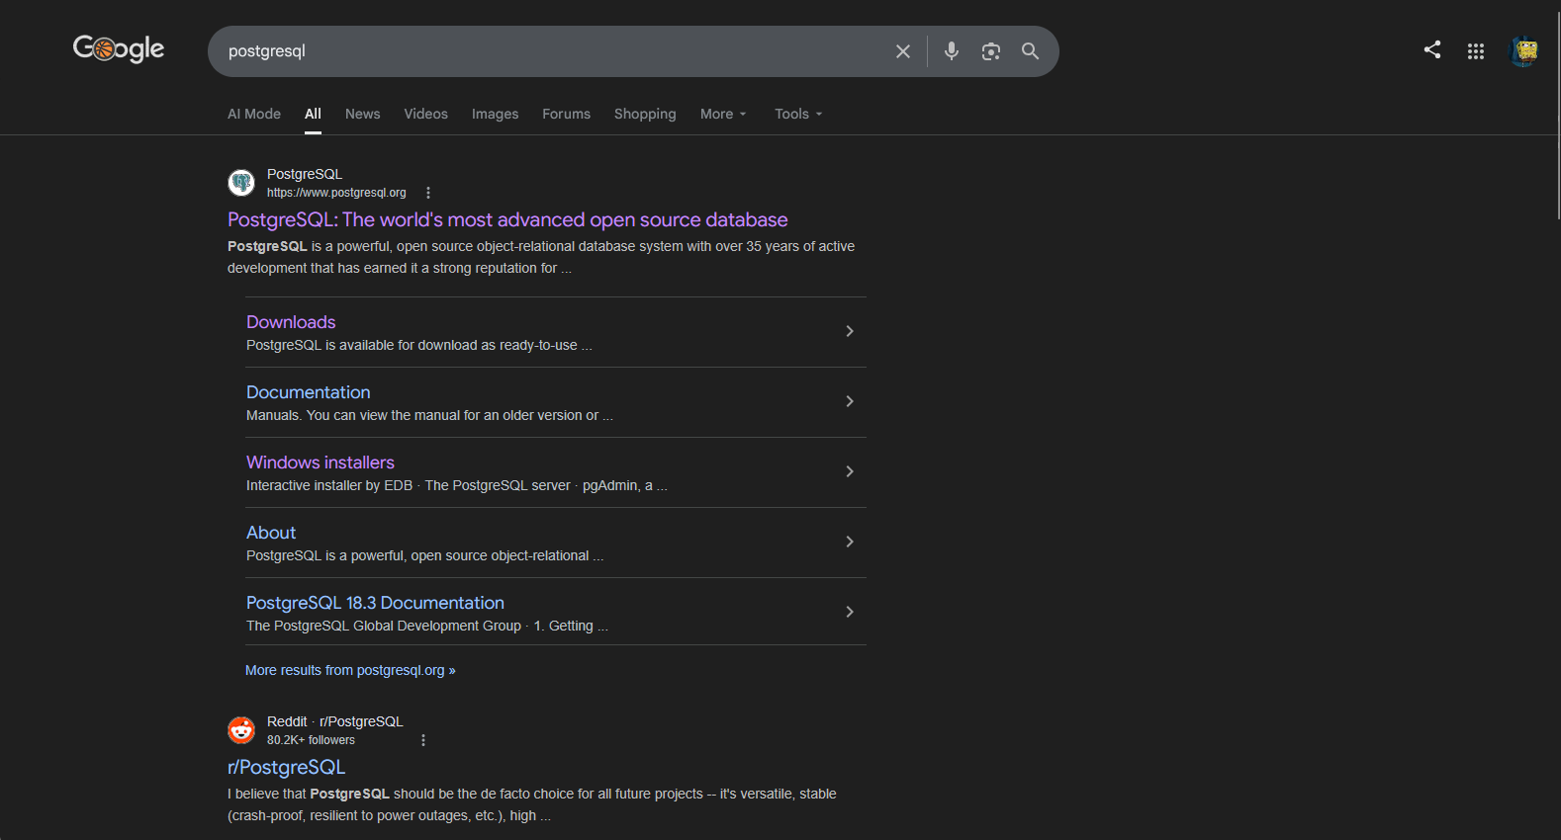

Navigate downloads
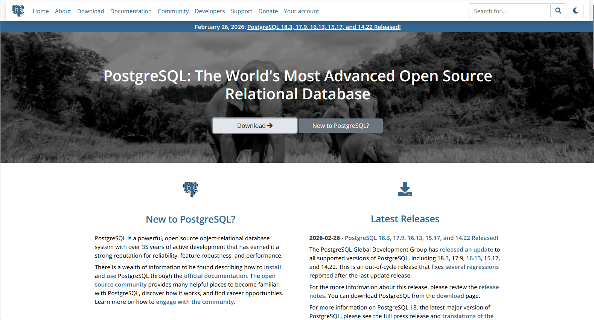

Click on Windows
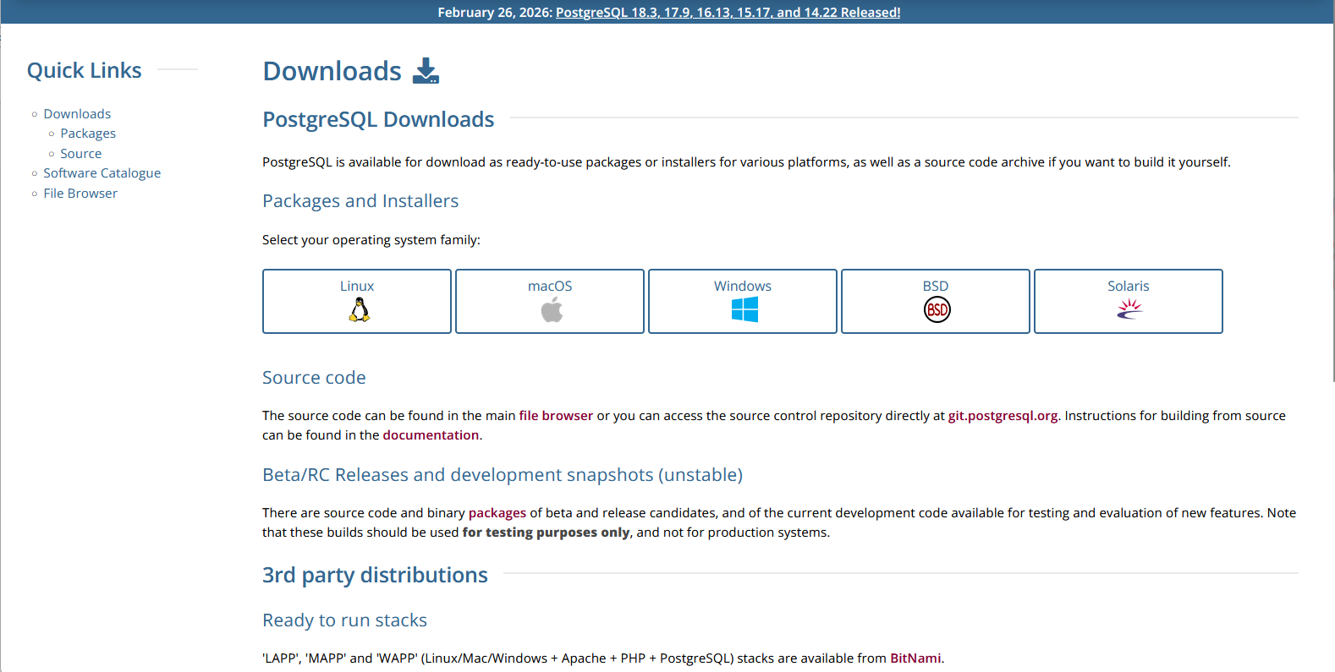

Find the hyperlink with text "Download the installer" and click the latest version
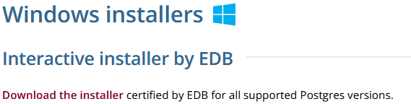

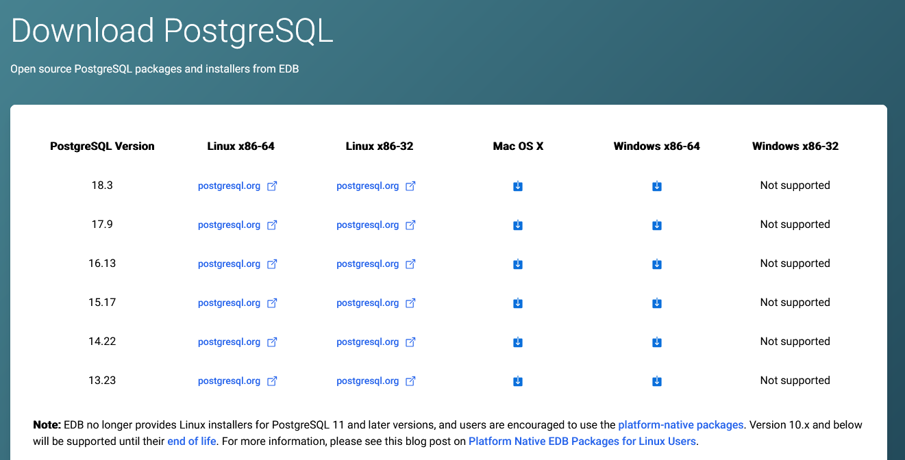

From here wait for the installer to finish downloading and run the installer
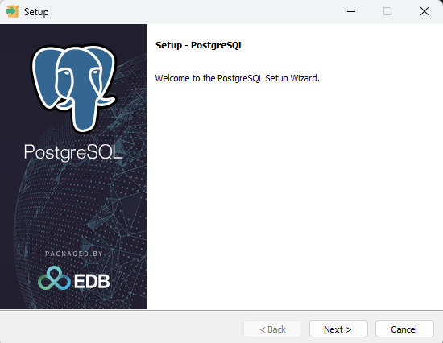
Hit next
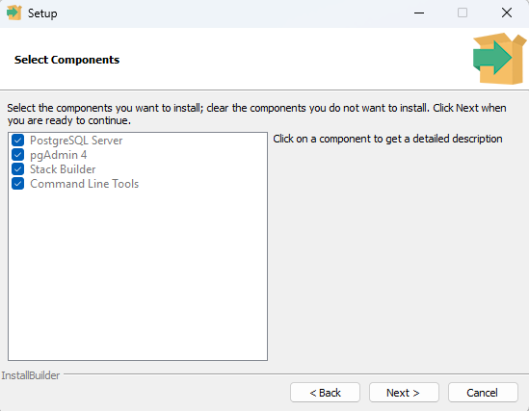
When prompted to create a password, make sure to remember the credentials created.
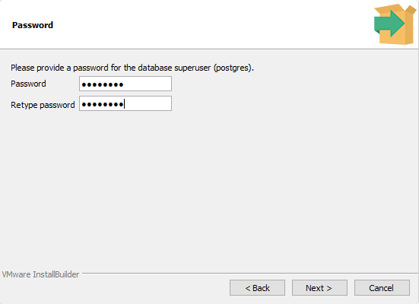
Hit next again until you reach the installation progress bar

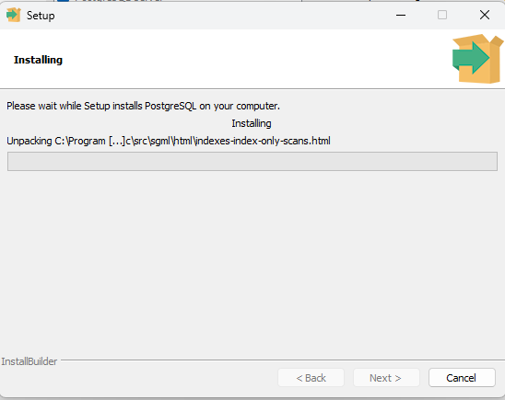
Wait till the installation is finished
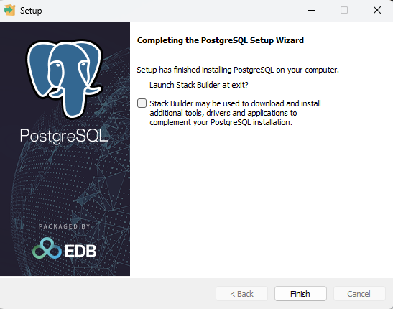
Uncheck the stack builder and hit finish, your PostgreSQL has successfully installed

Step 2:
Opening & setting up PostgreSQL
Navigate to your windows search bar and search for pgAdmin4
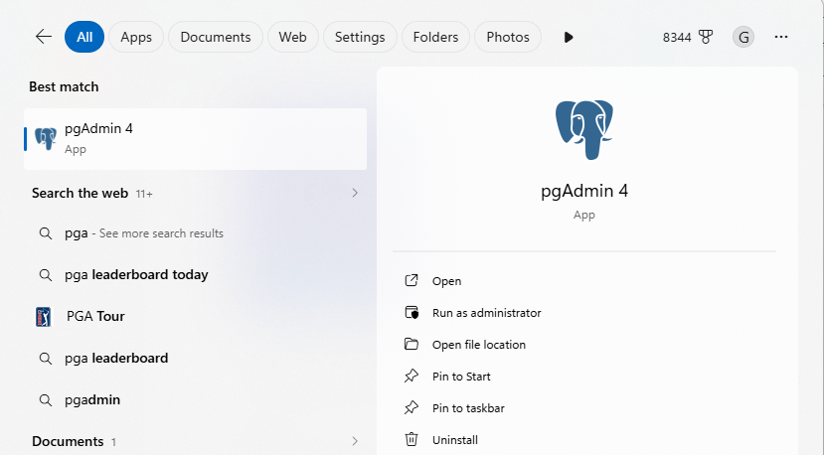
Click the pgAdmin 4 icon and wait for the launch of PostgreSQL
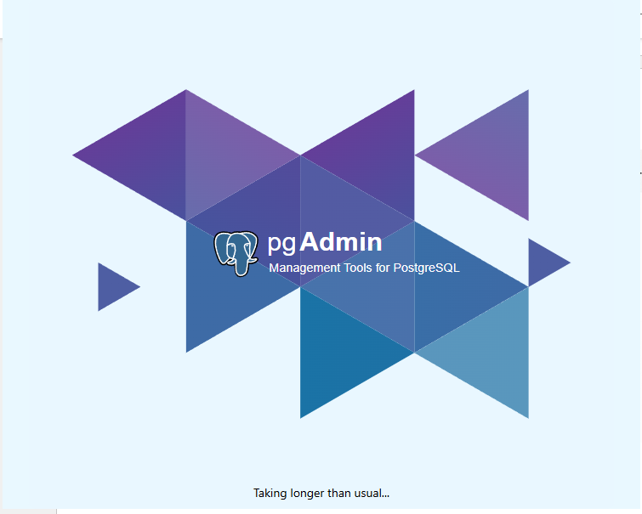
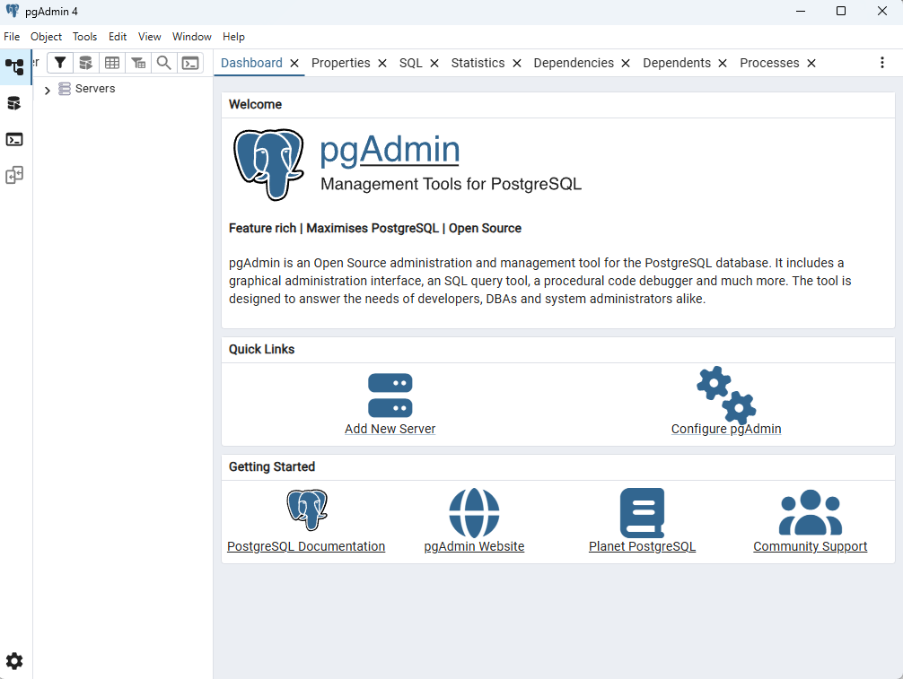
Click the Servers tag and then click the dropdown
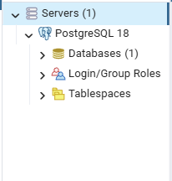
Right click the Databases tag and click create Database
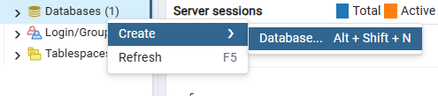
Name the database whatever you like, in my case I’ll do community_database and hit save
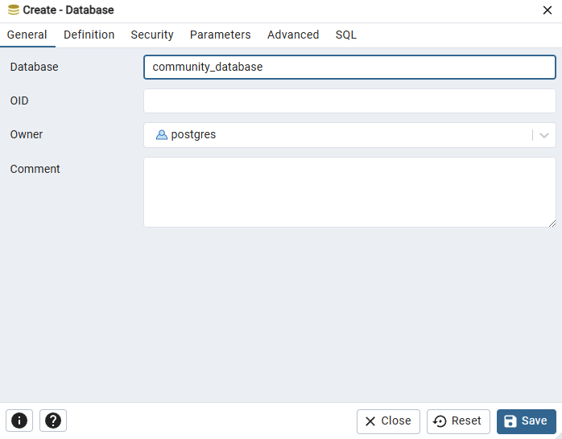
Now that the database is create we can add SQL data to it
Click the dropdown on databases and you can find the freshly created database
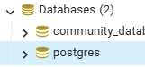
Click the community database and the dropdown as well
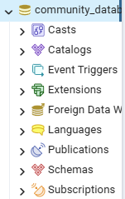
Head to the query tool up above
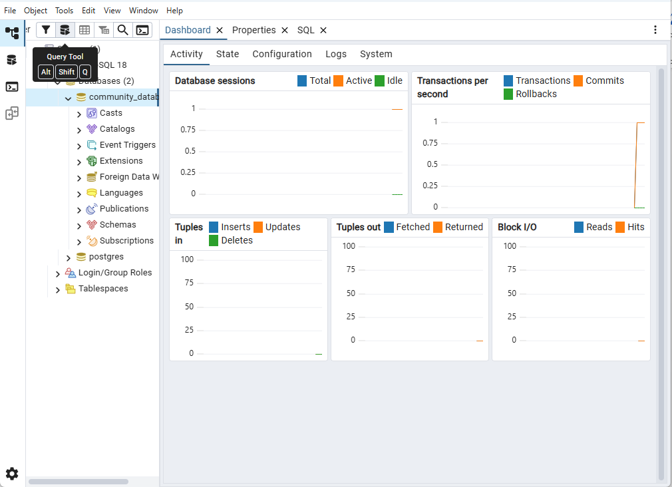
Click it and you’ll be given a tab that looks like this
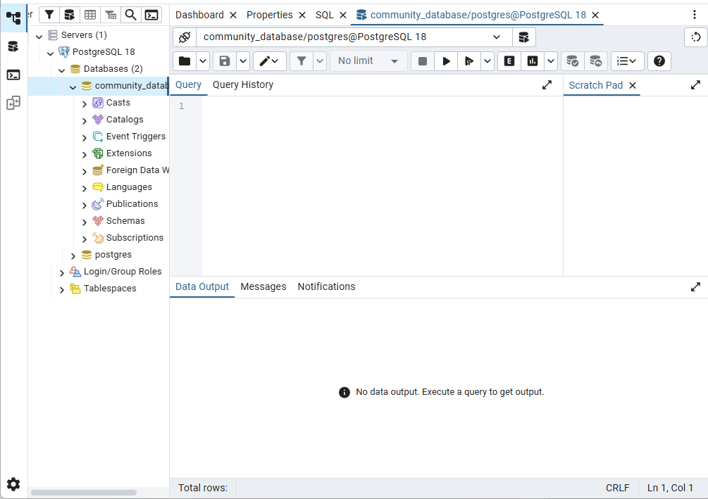
From here we can start using SQL to give shape to our database
Click the folder icon above and it’ll open the search function using windows explorer
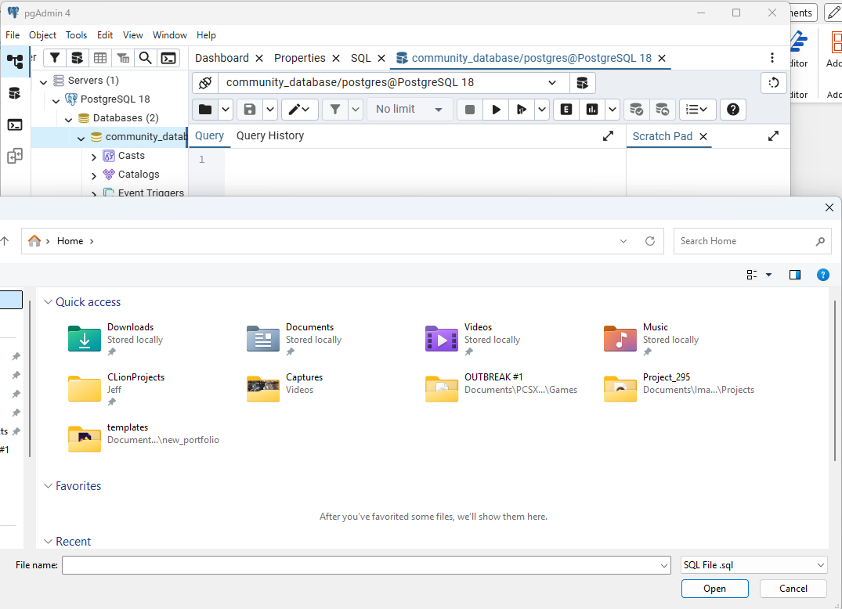
Navigate to where you saved the SQL Files folder and search for the Team-11-DDL in the folder and open that in pgAdmin4.
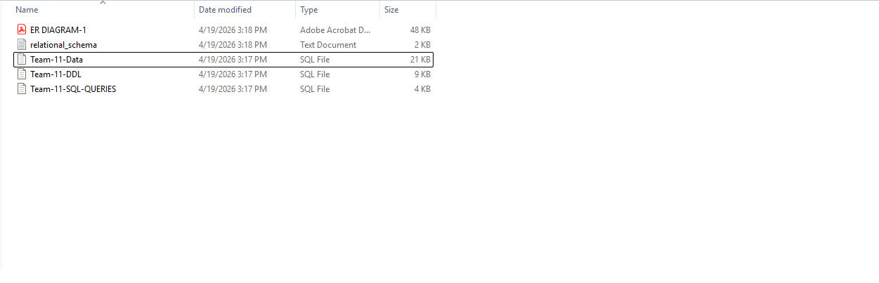
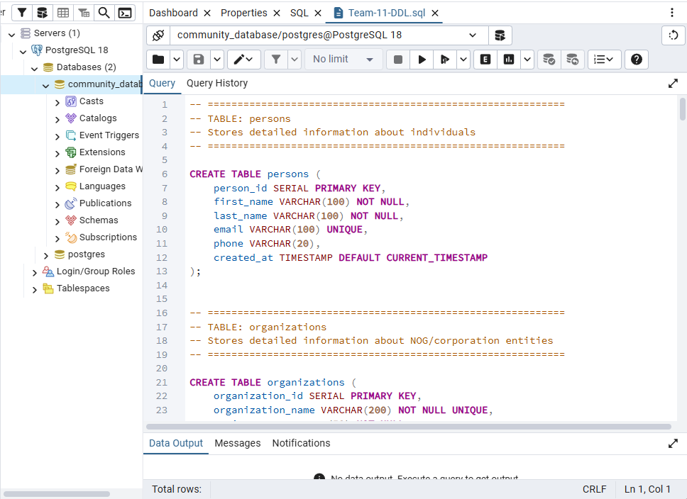
From here you want to run the table creation for the database
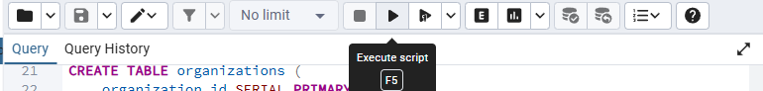
It will create all the tables for you, now we must populate the tables with data
Open the folder icon again and search for Team-11-Data and run that SQL to populate the tables
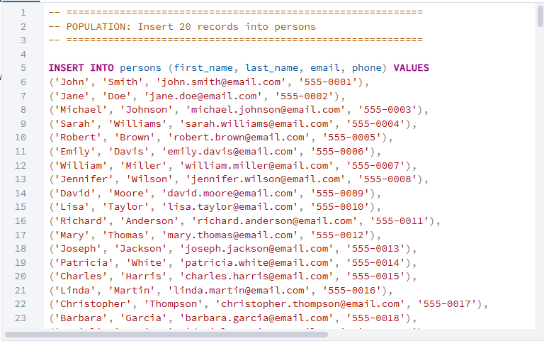
Now our tables have data we can use and work with
Next, we can mess around with our data created
We can open the Team-11-SQL-Queries file and see what we can do with the queries
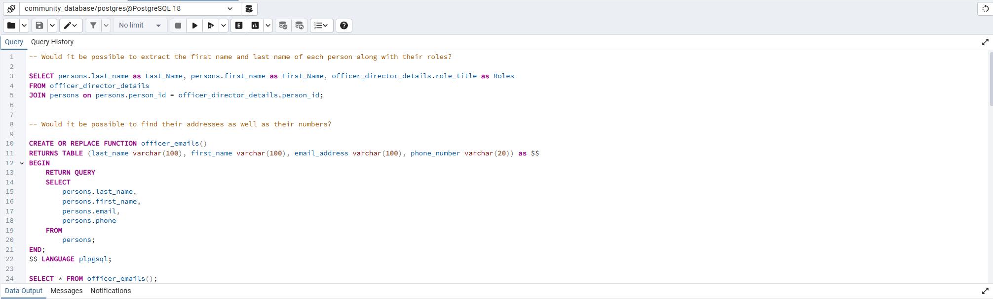
There are comments above each of the queries that prompt a question and the following query would give you the answer to the question, if you were to drag the lines for the query and hit run you can get the information
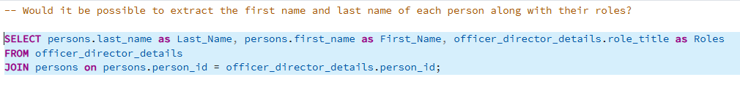
Click run after this, and you’ll be prompted with the resulting table
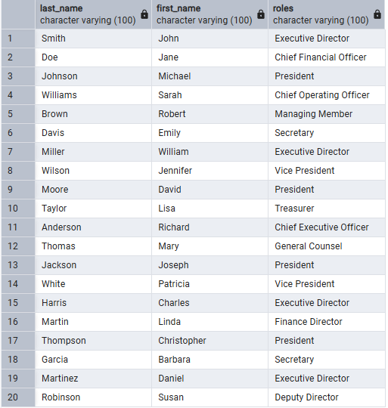
You can do the same for any of the other queries to get results, and that’s how you go about running the queries and receiving data

